`  


**INSTITUTE OF TECHNOLOGY OF CAMBODIA**

DEPARTMENT OF INFORMATION AND COMMUNICATION ENGINEERING

**PROJECT REPORT ON**

**Internet Programming**

“Covid-19 Information”

**Under The Guidance Of:**

Lecturer. CHHUN Thavorac

Lecturer. HOK Tin

**Group: 1**

**Team Members:**

BUT Dalin e20180044

BUN Arya e20180233

CHHENG Afa e02180106

CHHON Devit e20180113

EIV Lina e20180221

HAN Kimhak e20180248

HUN Ravit e20180328

HEL Sokheng e20180266

Ker Sokhun e20180374

**ACKNOWLEDGEMENT**

Without the people who volunteered their time and effort to assist and direct us, our three months of work on The Library website would not have been successful. We developed both our technical and soft abilities while working on this project. We want to let them know how much we value and appreciate them.

First and foremost, we would like to thank Lecturer. **Chun Thavorac** and Lecturer. **Hok Tin**, our course and TP instructors, for mentoring us during this project's duration. He has been very encouraging and helpful in providing suggestions, comments, and conversations as well as setting up meetings to track our project's development. He also provided us with some technical hints while we were struggling, which made

Additionally, he provided us with some technical advice while we battled, which helped us learn a lot. Last but not least, we would like to thank every member of our team who has consistently worked hard on this project with us, taught us how to function as a team, supported one another, and offered helpful suggestions for how to proceed.

In conclusion, I would like to express my gratitude to everyone who helped, encouraged, and supported us from the start of our initiative. Without them, we wouldn't be able to go over the obstacle.

**ABSTRACT**

We completed a three-month project on the library website as part of our learning during the second semester of our fourth year, which assisted all readers in reading online. For people who want to read and borrow books from anywhere they desire, The Library is a straightforward but useful service. The Library will include all features that enable users to utilize this website more quickly, learn new information, and feel secure. We completed all user and administrative capabilities after working on this project for around three months. After this project was over, there were a lot of things I learned from it that helped me and the team collaborate, develop many soft skills, and boost our confidence in our careers.

Contents

CHAPTER I: PROJECT INTRODUCTION 5

1. Introduction 5

2. Team Structure and Role 5

3. Project Features 6

4. Functionalities Requirements 6

CHAPTER II: ANALYSIS AND DESIGN 10

1. Choice of Technology 10

1.1. Technologies 10

1.2. Languages 11

1.3. Tools 11

3. System Structure 12

3.1. System Architecture Design 12

3.2 Database Design 13

CHAPTER III: IMPLEMENTATION 13

1. Project Setup and Installation 13

CHAPTER IV: Conclusion 15

1. Results 15

2. Experience 18

3. Perspective 18

4. Summary 18

CHAPTER V: History of Meeting 18

ANNEX: CAPTURE SCREEN 20

# CHAPTER I: PROJECT INTRODUCTION

## 1. Introduction

COVID-19 Information is a website that provides information and educational purposes. It is a news, social awareness and medical prevention website, which is specially created for providing daily Covid19 cases, social awareness and some news related to Covid19.

## 2. Team Structure and Role

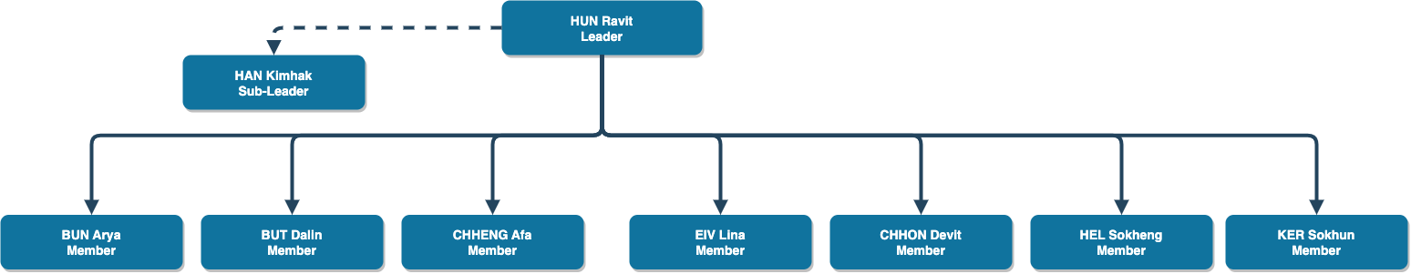

|  |  |  |
| --- | --- | --- |
| **Name** | **Member Role** | **Responsibility** |
| **HUN Ravit** | Leader | Developer(back-end) |
| **HAN Kimhak** | Sub-leader | Developer(back-end) |
| **BUN Arya** | Reporter | Developer(design) |
| **BUT DALIN** | Member | Developer(front-end) |
| **CHHENG Afa** | Member | Developer(front-end) |
| **EIV Lina** | Member | Developer(design) |
| **CHHON Devit** | Member | Developer(back-end) |
| **HEL Sokheng** | Member | Developer(design) |
| **KER Sokhun** | member | Developer(front-end) |

## 3. Project Features

COVID-19 Information Website features are:

* Get Latest Cases of Covid19
* Get Latest News Related to Covid19
* Map Visualization of Cambodia
* User can read, comment, and add news to their favorite
* User can share the information about news that they know
* User can find more detail about COVID19 symptoms, prevention, etc
* User can find Frequently Asked Questions and they can post their question
* Admin Can Manage Metadata for the system

## 4. Functionalities Requirements

In our system, there are two role of users which are Admin and User, so we have divided the functionality as below:

|  |  |  |
| --- | --- | --- |
| **User** | | |
| **Module** | **Feature** | **Description** |
| Authentication | Login | Users need to fill in their email address and password for The COVID19 website. |
| Register | This function allows the user to create their account on our website. For creating an account. First, a user needs to fill in some information such as username, email address, password and confirm password. |
| Forgot Password | When users forgot their password. They can reset it again by filling in their email address, wait a minute to get code for verification, and last fill their new and confirmation password. |
| Logout | When the user clicks log out, the data (token, information that related to the user) stored in the website will be clear. |
| Homepage | Total Cases related to COVID19 | Show daily cases of COVID19 |
| Cambodia Map Virtualization | COVID19 cases data on Map |
| Pie Chart | Illustrate COVID19 statistics |
| Graph | Illustrate COVID19 statistics |
| News | Read News | User can read news |
| Read and Post Comment | User can read and post comment |
| Add New to Favorite | User can add new to favorite |
| Add Comment | User can post comment |
| Filter by type | User can filter news by type |
| Search by title | User can search news by title |
| Vaccines | Info of Vaccination | Info related to Vaccination |
| FAQ | Read and Post Question | User can read FAQ by type and post their question |
| Contact Us | Send Message to Admin | User can send their message to the platform |
| Favorite | List favorite news | Get all user’s favorite news |
| Remove From Favorite | User can remove news from their favorite list |

|  |  |  |
| --- | --- | --- |
| **Admin** | | |
| **Module** | **Feature** | **Description** |
| Authentication | Login | Users need to fill in their email address and password for The COVID19 website. |
| Register | This function allows the user to create their account on our website. For creating an account. First, a user needs to fill in some information such as username, email address, password and confirm password. |
| Forgot Password | When users forgot their password. They can reset it again by filling in their email address, wait a minute to get code for verification, and last fill their new and confirmation password. |
| Logout | When the user clicks log out, the data (token, information that related to the user) stored in website will be clear. |
| Dashboard | Total Cases of COVID19 | Show daily cases of COVID19 |
| Pie Chart | Illustrate COVID19 statistics |
| Graph | Illustrate COVID19 statistics |
| News | Create | Admin can create news |
| Update | Admin can update news |
| Delete | Admin can delete news |
| FAQ | Create | Admin can create faq |
| Update | Admin can update faq |
| Delete | Admin can delete faq |
| Type FAQ | Create | Admin can create Type FAQ |
| Update | Admin can update Type FAQ |
| Delete | Admin can update Type FAQ |
| Dashboard | Total Cases related to COVID19 | Show daily cases of COVID19 |
| Cambodia Map Virtualization | COVID19 cases data on Map |
| Pie Chart | Illustrate COVID19 statistics |
| Graph | Illustrate COVID19 statistics |
| User | Create | Admin can create user |
| Update | Admin can update user |
| Delete | Admin can delete user |
| Contact | List | Admin can list contact from user |

# CHAPTER II: ANALYSIS AND DESIGN

## 1. Choice of Technology

### 1.1. Technologies

* **Node.js:** is an open-source, cross-platform, back-end JavaScript runtime environment that runs on the V8 engine and executes JavaScript code outside a web browser, which was designed to build scalable network applications.



* **Express.js**: Now we’re working on Express.js Framework version 4.17.3. Express.js is a minimal and flexible Node.js web application framework that provides a robust set of features for web and mobile applications.



* **Redis**: Redis is an open source (BSD licensed), in-memory data structure store, used as a database, cache, and message broker.
* **VueJs**: Vue.js is an open-source model–view–viewmodel front end JavaScript framework for building user interfaces and single-page applications.



* **MongDB**: MongoDB is a source-available cross-platform document-oriented database program. Classified as a NoSQL database program, MongoDB uses JSON-like documents with optional schemas.



### 1.2. Languages

* **Javascript**: is a lightweight, interpreted, or just-in-time compiled programming language with first-class functions.



### 1.3. Tools

* **Visual Code Studio:** Visual Studio Code, also commonly referred to as VS Code, is a source-code editor made by Microsoft for Windows, Linux and macOS. Features include support for debugging, syntax highlighting, intelligent code completion, snippets, code refactoring, and embedded Git.



* **Postman**: is a collaboration platform for API development. Postman's features simplify each step of building an API and streamline collaboration so you can create better APIs—faster.
* **GitLab**: GitLab Inc. is an open-core company that provides GitLab, a DevOps software package that combines the ability to develop, secure, and operate software in a single application.



* **Docker**: Docker is a set of platform as a service products that use OS-level virtualization to deliver software in packages called containers. The service has both free and premium tiers. The software that hosts the containers is called Docker Engine.



# 

* **DigitalOcean**: is an American cloud infrastructure provider headquartered in New York City with data centers worldwide. DigitalOcean provides developers, startups, and SMBs with cloud infrastructure-as-a-service platforms.

## 3. System Structure

In order to make our project work, we have to consider a lot about designing the system. We separate those design step into the following steps:

* Architecture Design
* Database Design

### 3.1. System Architecture Design

Considering the high availability and robust features of the system, we design the system into the services as below:

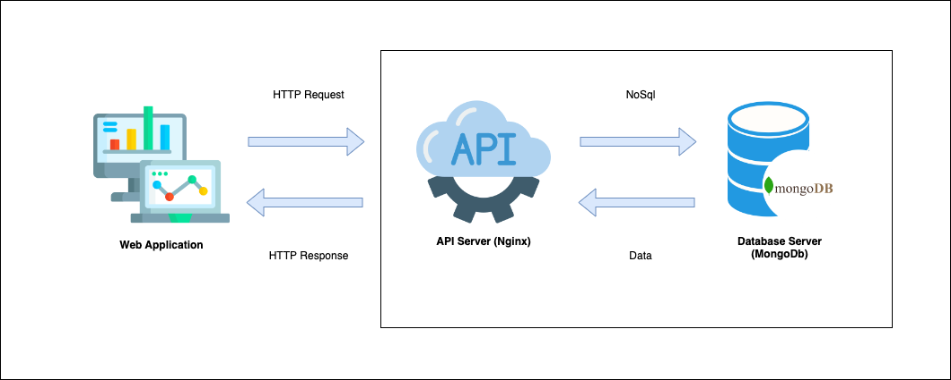

### 3.2 Database Design

For the database we use MongoDB Server. Here are our database schema:

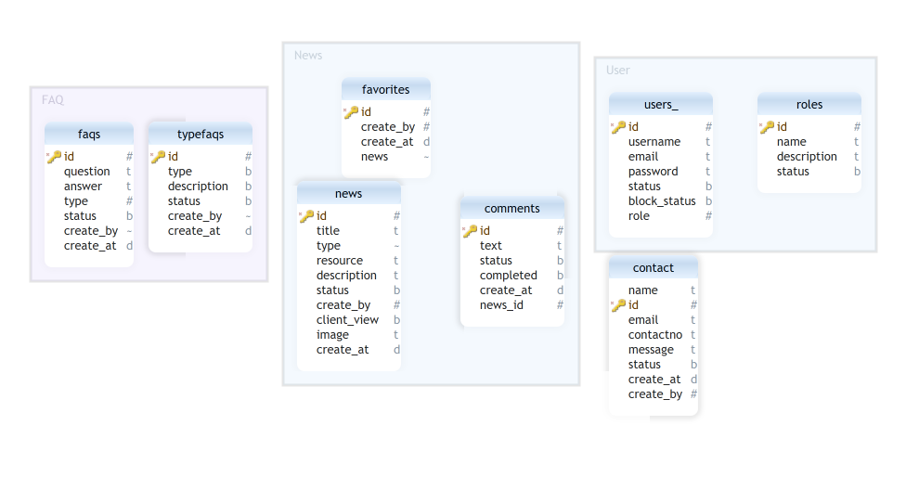

# 

# CHAPTER III: IMPLEMENTATION

## 1. Project Setup and Installation

* Backend

***npm install -g nodemon***

(Nodemon used for running our server without refresh)

For configuration, we need to create .env file to add some configuration as below in order to connect to database server

* Frontend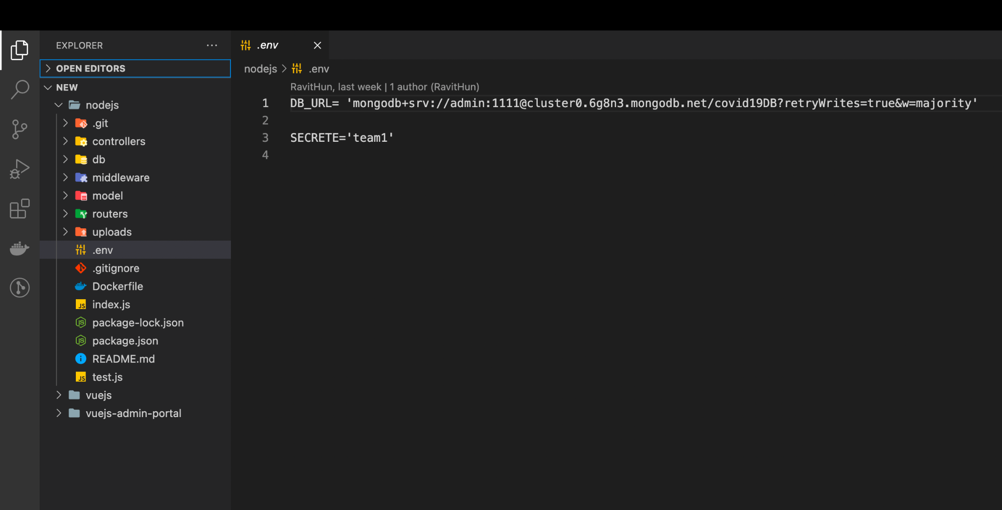

In order to run Frontend, we need to run these commands:

***vue create vuejs***

***cd vuejs***

***vue add vuetify***

For configuration, we need to create .env file to add some configuration as below in order to connect to our Backend 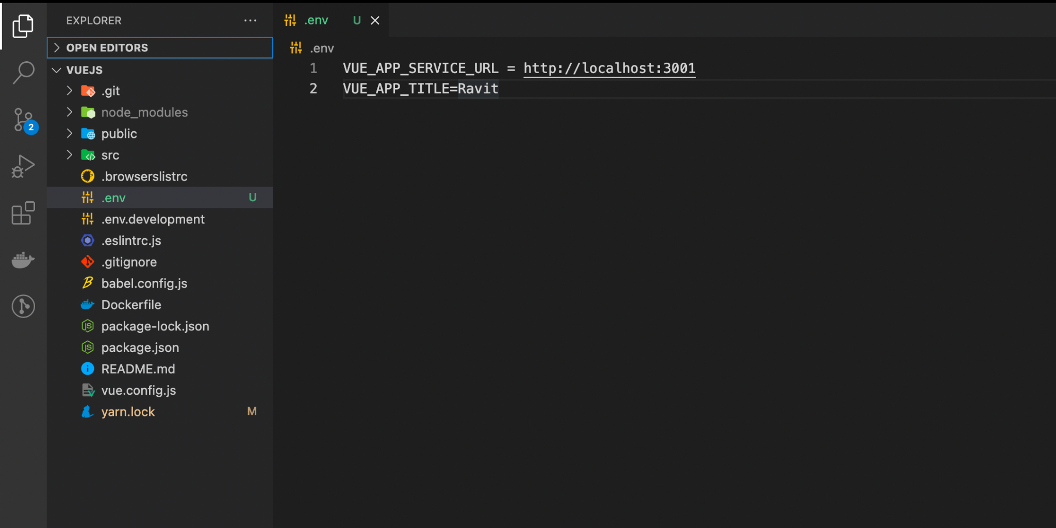

**2. Project Structure**

The basic organization of a project's files, directories, and subfolders is represented by the application structure. An overview of the application's structure will be shown to us when we establish the project, as illustrated.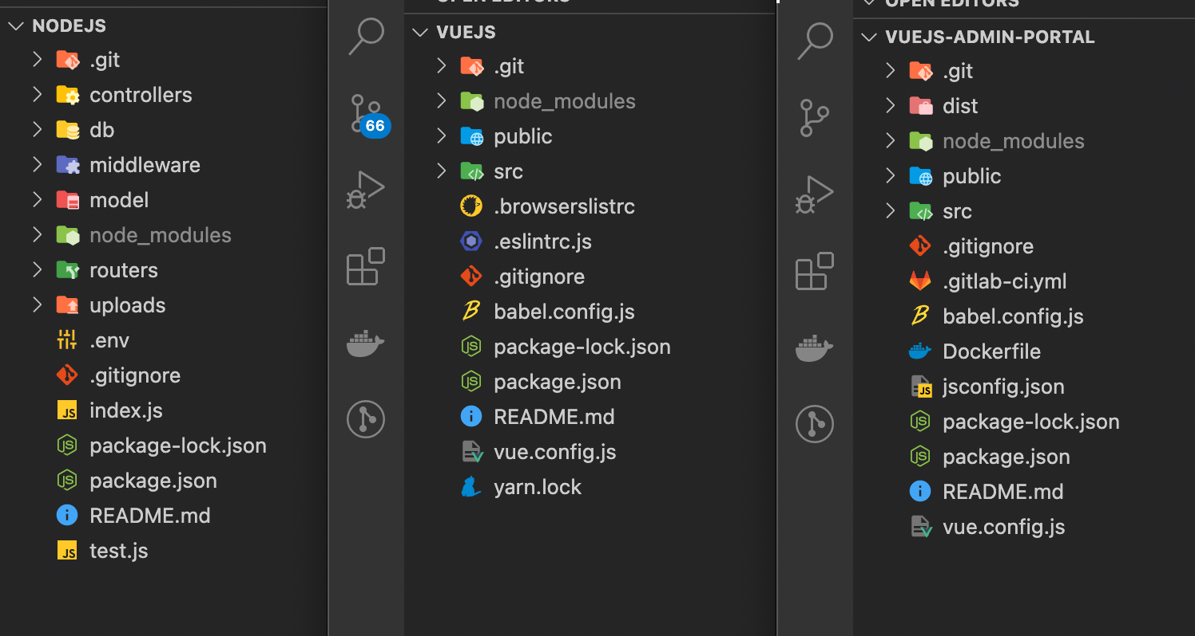

# CHAPTER IV: Conclusion

## 1. Results

After two months of working so hard on system Mock Up, Backend and Frontend, we finally have completed all the features that we have planned from the start.

* Code completed as planned
* Teamwork and communication went well
* The project finished in time
* Team members had good responsibility for their tasks and assigned the work punctually
* Team members had high commitment to do the project
* Everyone always participate in the meeting and discussion via Telegram and Microsoft Team as well as meeting in presence

|  |  |  |
| --- | --- | --- |
| **User** | | |
| **Module** | **Feature** | **Description** |
| Authentication | Login | Completed |
| Register | Completed |
| Forgot Password | Completed |
| Logout | Completed |
| Homepage | Total Cases related to COVID19 | Completed |
| Cambodia Map Virtualization | Completed |
| Pie Chart | Completed |
| Graph | Completed |
| News | Read News | Completed |
| Read and Post Comment | Completed |
| Add New to Favorite | Completed |
| Add Comment | Completed |
| Filter by type | Completed |
| Search by title | Completed |
| Vaccines | Info of Vaccination | Completed |
| FAQ | Read and Post Question | Completed |
| Contact Us | Send Message to Admin | Completed |
| Favorite | List favorite news | Completed |
| Remove From Favorite | Completed |

|  |  |  |
| --- | --- | --- |
| **Admin** | | |
| **Module** | **Feature** | **Description** |
| Authentication | Login | Completed |
| Register | Completed |
| Forgot Password | Completed |
| Logout | Completed |
| Dashboard | Total Cases of COVID19 | Completed |
| Pie Chart | Completed |
| Graph | Completed |
| News | Create | Completed |
| Update | Completed |
| Delete | Completed |
| FAQ | Create | Completed |
| Update | Completed |
| Delete | Completed |
| Type FAQ | Create | Completed |
| Update | Completed |
| Delete | Completed |

## 2. Experience

During this project, we have faced some problems as some of the members could not get what we were going to do at first. However, we all had high responsibility for our work. This project was not as easy as we expected since it contained a lot of functionalities and we needed to have a deep understanding of every part of it. Therefore, we have spent a lot of time reviewing and researching more for this project. To make sure that our system would work well, we always had online meetings via Microsoft Teams and doing the task together at school as well. We tried to make as many meetings as possible to discuss our project. All the problems we faced, we tried to solve it step by step as much as we could. Every member has worked so hard as a group, we also kept solidarity and patience. We kept going on however we met the obstacle ahead. Everyone has completed the tasks on the date we have determined. After almost a month of working together with a lot of experience, we were able to finish the project as we expected.

## 3. Perspective

Our idea is incredibly interesting, so if we get the chance to continue working on it, we'd like to expand it even more. Additionally, this effort will make it easier for many people who enjoy devoting their free time to reading to help without going directly.

## 4. Summary

In conclusion, it was a wonderful learning experience for us while working on this project. This project has taken us through the various phases of working as a team and also gave us real insight into another level of the IT world. Finally, we want to say congratulations and thanks to our team for finishing the project. We, in the name of GIC students, would like to say thanks to our dynamic lecturer who always gives us a lot of advice and guides the direction to do the project until we are able to accomplish it as well.

# CHAPTER V: History of Meeting

|  |  |  |  |  |
| --- | --- | --- | --- | --- |
| **No.** | **Date** | **Meeting Location** | **Attendance** | **Task** |
| **1** | 15/03/2022 | MS Team | Absent 1 | * Divide work to team project * Design UI about Login and Register |
| **2** | 17/03/2022 | MS Team | Absent 1 | * Create Repository * Start Login and Register * Continue design * Give tas to do |
| **3** | 21/03/2022 | MS Team | All members are joined | Meeting and Upload into git |
| **4** | 23/03/2022 | MS Team | All members are joined | * Meeting and talk more about our project * Divide work to team project for research more information |
| **5** | 24/03/2022 | MS Team | All members are joined | Meeting and doing on front-end with their own part |
| **6** | 28/03/2022 | MS Team | Absent 4 | Meeting and checking the front-end for each member. |
| **7** | 04/04/2022 | MS Team | All members are joined | Meeting and research more resource and information |
| **8** | 06/04/2022 | MS Team | All members are joined | Meeting and design more UI for more attractive |
| **9** | 25/04/2022 | MS Team | All members are joined | Meeting and talking about Veu-JS and back-end |
| **10** | 26/05/2022 | MS Team | All members are joined | Meeting and prepare for presentation |

# 

# ANNEX: CAPTURE SCREEN

**User Panel**

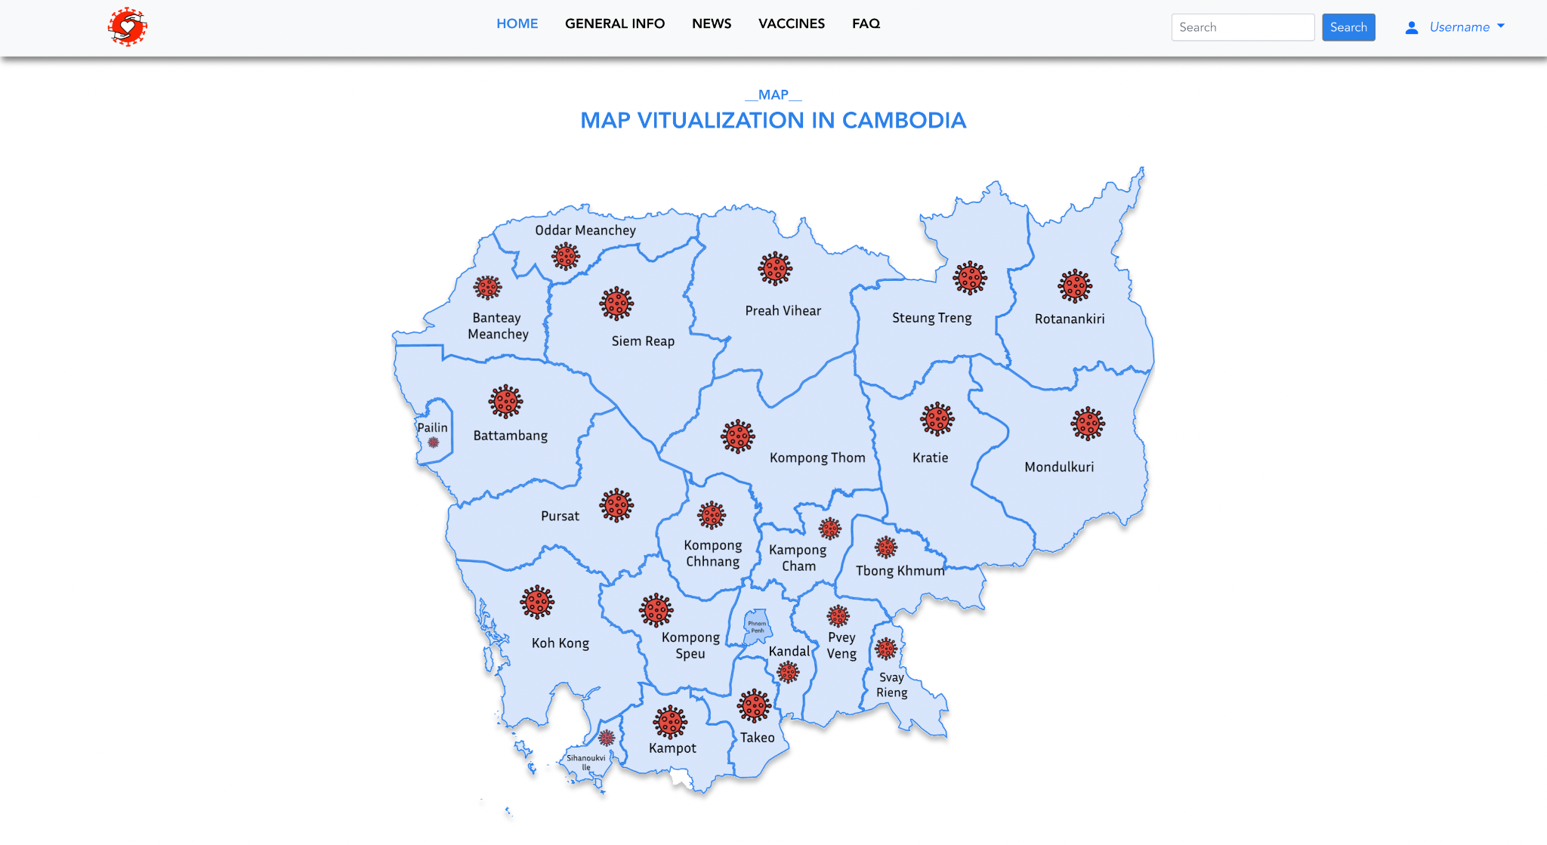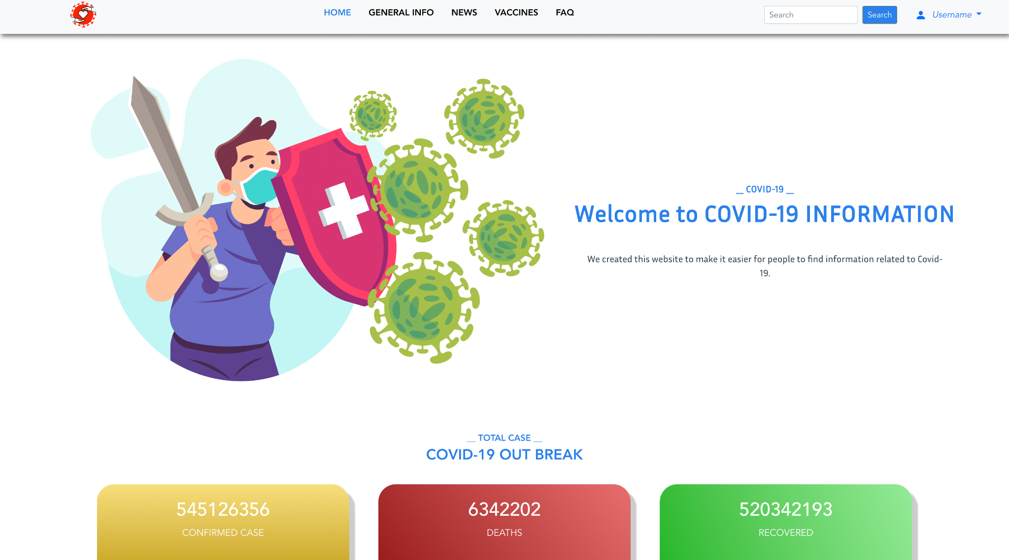

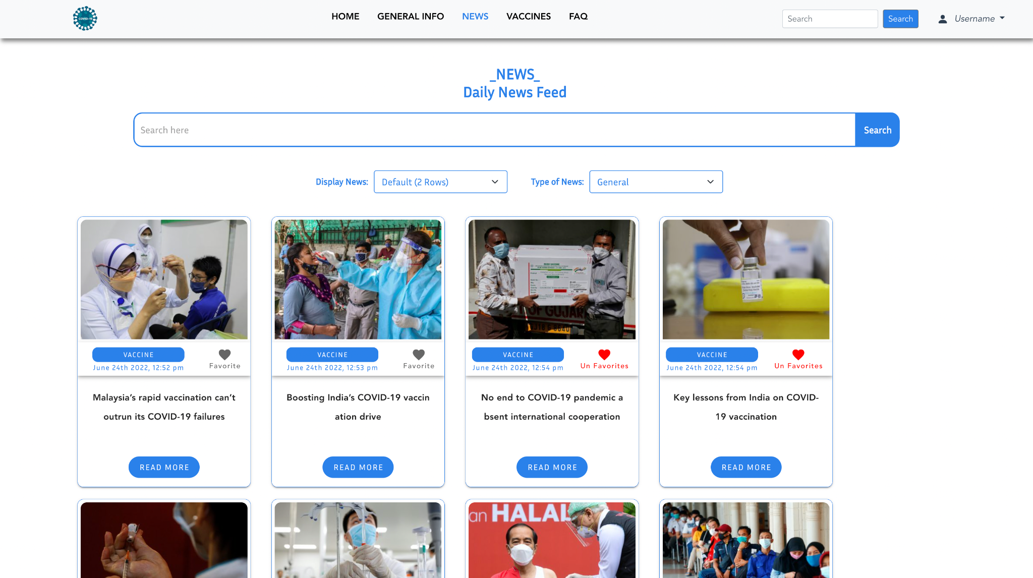

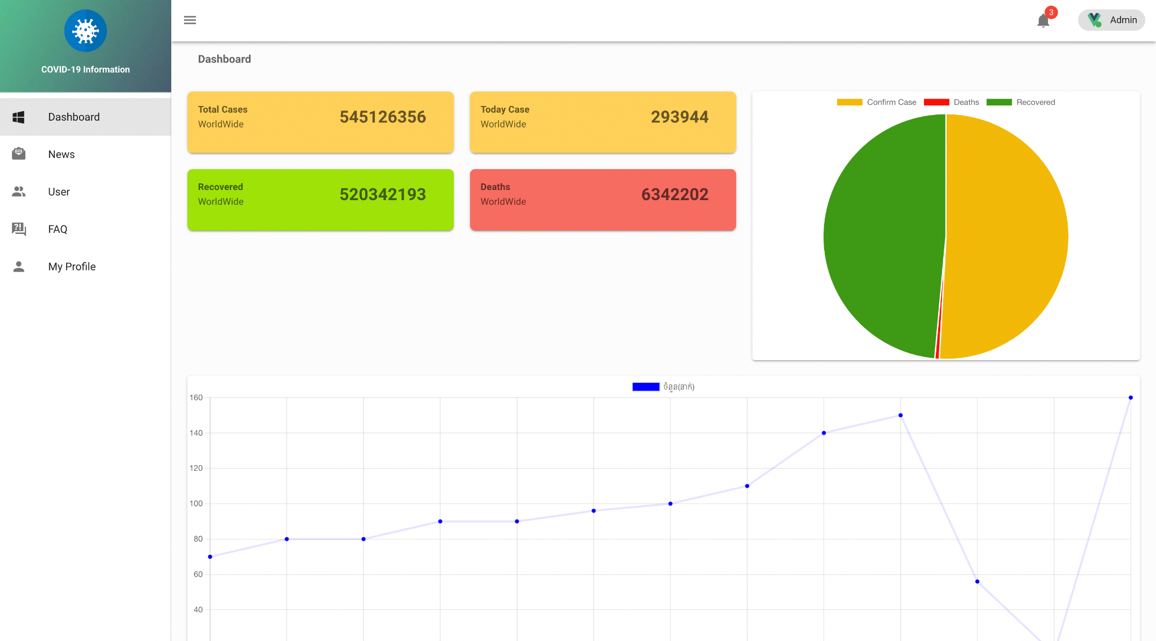**Admin Panel**